МИНИСТЕРСТВО ОБРАЗОВАНИЯ И НАУКИ ЧЕЛЯБИНСКОЙ ОБЛАСТИ
государственное бюджетное профессиональное образовательное учреждение
«Магнитогорский педагогический колледж»



ПРАКТИЧЕСКИЕ РАБОТЫ
по дисциплине
«ОУП.04 Иностранный язык»
для студентов специальности
44.02.02 Преподавание в начальных классах

Разработали:
Омеленчук К.А.,
преподаватель иностранного языка;
Дрозд Н.В.,
преподаватель иностранного языка
ГБПОУ «МПК»

Магнитогорск, 2025

СОДЕРЖАНИЕ

Тема 2.1. Современный мир профессий. Проблемы выбора профессии. Роль иностранного языка в вашей профессии 3

Тема 2.2 Искусство и культура 13

Тема 2.3 Технический прогресс: перспективы и последствия. Современные средства связи 33

Тема 2.4 Выдающиеся люди родной страны и страны/стран изучаемого языка, их вклад в науку и мировую культуру 45

Тема 2.5 Деловое общение 57

Тема 2.1.

Современный мир профессий. Проблемы выбора профессии.

Роль иностранного языка в вашей профессии

Exercise 1. Translate the words and make up sentences using them.
Actor, banker, teacher, doctor, pilot, hairdresser, interpreter, cook, secretary, surgeon, lawyer

Exercise 2. Read the statements and guess the professions.
- Someone who teaches the children at school. It’s a teacher.
- Someone who works in the bank
- Someone who plays on the stage
- Someone who operates on people
- Someone who cures people
- Someone who translates the text and the speech
- Someone who controls a plane
- Someone who cuts hair
- Someone who makes the dish
- Someone who is the right hand of the director
- Someone who defends your rights
Exercise 3. Correct the sentences, changing the word denoting profession if it is not correct.
- Doctors teach children.
- A pilot drives a car.
- A farmer works on a farm.
- Teachers work at school.
- A fireman brings letters.
- Workers bake bread.
- A programmer fights fires.
- Dancers work in the hospital.
- Clowns work in the circus.

Exercise 4. Translate the verbs in the box and fill them in the gaps.
fights, drives, work, cooks, brings, flies, protects, cures
- A postman … letters.
- A policeman … people.
- A fireman … fires.
- My mother … cakes well.
- His father … a car.
- An astronaut … in a spaceship.
- Teachers … at school.
- A vet … sick animals.
Exercise 5. Match the words and phrases with their definitions.
Curriculum | Organization and maintenance of an effective learning environment.
Lesson Plan | Different ways individuals absorb, process, and retain information.
Differentiation | Adapting teaching approaches to accommodate individual learners' needs.
Instructional Methods | Meeting between educators and guardians to discuss children's progress and development.
Standardized Testing | Ongoing training and education to enhance teaching skills and knowledge.
Classroom Management | Strategies employed to maintain discipline and promote positive behavior in classrooms.
Behavior Management | Detailed outline of lessons covering objectives, activities, assessments, and materials.
Learning Styles | The planned educational content and structure for teaching subjects in schools.
Parent–Teacher Conference | Uniform tests administered across multiple locations to measure students' abilities.
Professional Development | Various techniques used to deliver content, e.g., lectures, demonstrations, group work.

Exercise 6. Divide these skills into soft skills and hard skills.
Adaptability
Attention to Detail
Behavior Management
Classroom Management
Content Knowledge
Communication
Collaboration
Creativity
Critical Thinking
Data Analysis
Empathy
Interpersonal Skills
Leadership
Negotiation
Project Management
Photography
Problem-Solving
Presentation Skills
Resilience
Time Management
Exercise 7. Read and translate the text.
«SCHOOL LIFE»
Children begin to study at school at the age of six. School year begins on the 1st of September – it is the Day of Knowledge. Children go to school smart and nice with their bags and flowers, some of them wear uniforms and some don’t.
Classes usually begin at 9 o’clock in the morning, and pupils have 5 or 6 lessons every day. There are many different subjects in the timetable. Children study Russian, Literature, English, Math, History, Geography, Biology, Chemistry, Physics and other subjects. They usually have lunch at school canteen. Pupils study one or more foreign languages. At their English lessons children read stories, translate them, learn new words, write dictations and tests, sing English songs. When classes are over children can go in for sports, dancing, drawing and have other activities. They often visit museums, theatres, cinemas and other interesting places with their teachers.
Schoolchildren have autumn, winter and spring holidays. Summer holidays are the best time for pupils. They swim in the river, go to the seaside with parents or to the countryside to visit their grandparents.

Exercise 8. Choose the sentences which were used in the text.
1. A) The 1st of September is the Day of Knowledge.
B) The 1st of January is the Day of Knowledge.
2. A) Classes usually begin at 9 o’clock
B) Classes usually begin at 8 o’clock
3. A) Children start to study at the age of 6
B) Children start to study at the age of 7
4. A) Schoolchildren have holidays in summer and winter
B) Schoolchildren have holidays in summer, autumn, winter and spring

Exercise 9. Complete the sentences according to the text.
1. Pupils read and translate texts, learn new words at…
2. There are many different subjects in the...
3. Children begin to study at school…
4. Children have lunch…

Exercise 10. Say if the sentences are true or false.
1. Children have 6 lessons every day.
2. The first of September is the Teacher’s Day.
3. Summer holidays are the best time for pupils.
4. After school pupils do their homework and go to bed.

Exercise 11. Answer the questions.
1. When do the children begin to study a school?
2. How do the children spend their holidays?
3. What do the pupils do after classes?
4. What subject do they study at school?

Exercise 12. Translate into English
1. Дети идут в школу нарядные и красивые.
2. Дети часто ходят в музеи, театры и кинотеатры с учителями.
3. Дети кушают в школьной столовой.
4. На уроках английского ученики читают рассказы, переводят их, учат новые слова и пишут диктанты.

Exercise 13. Read and translate the text.
My unusual student
I would like to begin my story with the following words: "Someone understands what they want from their youth and consciously moves along the rails of college-practice-work. Someone is led by those same inscrutable paths that are impossible to calculate and foresee." Unfortunately, I do not know whose words these are, but they are very suitable for me.
Since early childhood, I dreamed of becoming a teacher. My brother and I always played school, and in my dreams everything was always wonderful. How interesting it was to teach, give some assignments, feel and sense myself as the main person in the lives of other people. But only now I understood what it means to be a "teacher". It is not only to teach other children, but also to educate. After graduating from college, I got a job.
How much joy was in my eyes? My first class and I: their first teacher. I will not hide, there was both pride and fear. But the most interesting thing began later ... We met little first-graders. And I saw that not everything is as good and wonderful as it seems at first glance. Children are all different and you need to find a special approach to each one. You need to devote time to each one, but one of my students demanded constant attention. And then my “holiday” began, almost every day. I thought that I would not be able to stand it and would run away from school. Every day I had trials and tests of strength from one student. He threw desks, threw chairs, ran and jumped during lessons. I increasingly began to think that I was a bad teacher, that I could not find an approach to such a child. He disrupted lessons, shouted, even in the cafeteria his behavior did not change.
Days passed and patience gradually ran out, but I just gave up. Honestly, I just gave up. I used a lot of information and soon realized one thing, you need to perceive him as he is: capricious, impatient, but kind and honest, as I realized later. And so, I taught the 1st grade, we moved to the 2nd... Time passed. In the class, the children had responsibilities: a class monitor, a deputy class monitor and a person responsible for discipline. All the children changed, a little, but still matured. And my student changed too. He started to listen, to understand what I was saying - that's when I realized that there is a key to every child. And I finally found it for him.
Now my unusual student, as it seemed to me at the beginning of my professional way, has changed and shown what he really is. Imagine, I assigned him to monitor discipline in the class. He himself violated it, and now he himself observes it and monitors others so that they do not violate anything either.
With this small victory, I achieved what I wanted for so long. I realized that a teacher is a multifaceted person. He must be a psychologist to understand and accept all the psychological problems of a child. He must be an educator to teach a little person to distinguish good deeds from bad. He must be an actor to not show his weaknesses, which everyone has. He must be a "clown" to cheer up children. And most importantly, a real teacher must be a friend to a child, so that he goes to school with desire. And then everything will be fine. I understood all this, but I accepted it only now - when all my efforts towards this student achieved their goal.

Exercise 14. Answer the questions.
1. What did the girl dream of becoming?
2. What games did she play with her brother in her childhood?
3. What feelings did she experience when she imagined herself as a teacher?
4. What did she have to understand and see when she became a teacher?
5. What difficulty did the young teacher have to face?
6. What was this boy like, how did he behave?
7. How did the young teacher achieve success?
8. What conclusion did you draw from this story?

Exercise 15. Translate into English
1. С самого раннего детства я мечтала стать учителем.
2. После окончания колледжа я устроилась на работу.
3. Не скрою, была и гордость, и страх.
4. Мы познакомились с маленькими первоклассниками
5. Дети все разные и к каждому надо найти свой особый подход.
6. Каждый день у меня были испытания и проверка на прочность.
7. Он срывал уроки, кричал, даже в столовой.
8. Я поняла, что учитель – это многогранный человек.
9. Учитель должен быть психологом, чтобы понять все психологические проблемы у ребенка.
10. А самое главное, настоящий учитель должен быть ребенку другом, чтобы он с желанием шел в школу.

Exercise 16. Learn the verbs with -ing and infinitive.
https://quizlet.com/ru/1100635294/%D0%B3%D0%B5%D1%80%D1%83%D0%BD%D0%B4%D0%B8%D0%B9-%D0%B8-%D0%B8%D0%BD%D1%84%D0%B8%D0%BD%D0%B8%D1%82%D0%B8%D0%B2-flash-cards/?i=3jsah5&x=1jqt

Exercise 17. Write the composition «My future profession» (80-120 words).

Exercise 18. Role play.
Student 1. You are considering applying for a part-time job as an elementary teacher at preschool club and now you'd like to get more information. In 1.5 minutes you are to ask four direct questions to find out about the following:
1. location
2. job requirements
3. work schedule
4. employee benefits
Student 2. You are an owner of a preschool club. You are going to provide an interview. You have to answer 4 questions. Give full answers to the questions (2-3 sentences).

Exercise 19. You have received an email message from your English-speaking pen-friend Jemma:
From: Jemma@mail.uk
To: Russian_friend@mail.ru
Subject: future plans
... I've been thinking a lot about my future career choices lately. It's pretty nerve-wracking. Then I came across your decision to become an elementary teacher, and I found it fascinating! What inspired you to pursue a career in elementary education? Were there any specific moments or experiences that influenced your choice? What advice would you give someone considering this profession?

Write an email to Jemma.
In your message:
- answer her questions;
- write 100-140 words.
Remember the rules of email writing.

Тема 2.2

Искусство и культура

Exercise 1. Read and translate the text.

ART
Art is defined in encyclopaedias as the process and result of making material works, which reflect beauty or reality. The 'creative arts' denote a number of disciplines whose purpose is to create material things which reflect a message, mood, and symbols for the viewer to interpret.
Art includes various forms such as prose writing, poetry, dance, acting, sculpture, painting, music, etc. The term 'arts' often means 'fine arts' — painting, sculpture, drawing, engraving. Installation art, furniture, industrial design, graphic design and others are included in applied arts. There are a variety of arts, including visual arts and design, decorative arts, plastic arts, and the performing arts. Artistic expression may take many forms: painting, drawing, printmaking, sculpture, music and architecture. New forms include photography, film, video art, conceptual art, performance art, land art, fashion, comics, computer art. Within each form, a wide range of genres may exist.
Of all the forms of art, I prefer painting and music. I am really interested in painting for several reasons. Firstly, it is one of the oldest forms of art. Humans have been painting for about 6 times as long as they have been writing. The oldest painting found is over 32,000 years old. Painting is a form of art which is believed by many to express feelings and ideas in the visual form. Using visual images — colours, light and shade, forms and shape, a painter makes us understand his concept of life, share his feelings and enjoy the beauty of the world. Secondly, painting offers you a wide choice of styles, it allows us to be as specific or abstract as we please. From the wide range of various art schools and styles (realism, impressionism, cubism, fauvism, surrealism, modernism, pop art, etc.) you can choose one to your liking. The art schools I prefer are realism and impressionism, as I think they depict form and mood in the most distinct and vivid way.
The second form of art I am really keen on is music. The term 'music' is difficult to define. It can be explained, for example, as the art of making pleasing combinations of sounds in rhythm, harmony and counterpoint. The music that composers make can be heard through several media; the most traditional way is to hear it live, in the presence of performers. Live music can also be broadcast over the radio, television or the internet. Firstly, music helps me relax and relieve stress. When I listen to music, classical, jazz, rap or any other type of music I enjoy, I forget about the troubles of everyday life; music provides an escape from everyday problems. Stress melts away as I am taken in by the beauty of the music. It can help me feel calm and deeply relaxed. Secondly, music affects my emotions. Each type of music sets distinct mood and changes mine. In doing so, it appeals both to my mind and to the subconscious. Whether I am feeling sad, frustrated or confused, I listen to merry or tender music, and my mood shifts.
There are many divisions and groupings of music. Among the larger genres are classical music, popular music or commercial music, country music and folk music. Classical music is sophisticated and refined, but it is a universal form of communication, it historically was the music of the upper strata of society. Popular music is music belonging to any of a number of musical styles that are accessible to the general public; it is mostly distributed commercially. It is sometimes abbreviated to pop music, although pop music is more often used for a narrower branch of popular music. Pop music is usually memorable, with voices, lyrics, instruments creating catchy tunes. Pop music attracts listeners through easy sound images.

Exercise 2. Translate the following sentences into English.
1. Из всего безграничного многообразия видов искусства я предпочитаю живопись и музыку.
2. Искусство пользуется популярностью у многих людей, поскольку оно отражает красоту мира.
3. Изобразительные искусства включают живопись, рисунок, гравюру, скульптуру и ряд прикладных видов искусства, таких как инсталляция, промышленный дизайн, графический дизайн и т. д.
4. Художественное выражение принимает традиционные формы, такие как живопись, скульптура, музыка и архитектура, а также ряд новых форм, таких как фотография, видеоискусство, концептуальное искусство, ландшафтный дизайн и т. д.
5. Зрительные образы, которые использует художник, такие как цвет, свет, тень, форма, выражают его видение жизни.
6. Важнейшими элементами музыки являются звуки, ритм, гармония и контрапункт.
7. Музыка включает множество жанров (разновидностей), таких как популярная, или коммерческая музыка, музыка кантри, классическая музыка.
8. Классическая музыка раньше была музыкой высших слоев общества, популярная музыка доступна широкой аудитории.

Exercise 3. Answer the questions.

1. Are you interested in art? What art in particular?
2. Painting and sculpture are visual arts, aren’t they? Which of them is more exciting for you?
3. What world-famous artists do you know/like?
4. Who is your favourite painter? Why?
5. Which of the two genres — portrait or landscape painting — attracts you more? Do you know any well-known portraitists? landscapists?
6. Many artists produced pictures of scenes at sea. Can you say that Aivazovsky was a famous Russian seascapist? Do you know any names of his pictures?
7. Do you know any British museums?
8. Do you ever go to picture galleries and art museums? Which galleries/museums? What important picture galleries and art museums do you know in Russia and abroad?
9. Where can we see sculptures? Where are they usually placed and why?
10. Do you think photography can be called a visual art? Why? Why not?
11. Have you ever tried your hand at any of these three arts — painting, sculpture and photography? How successful were you?

Exercise 4. Вставьте подходящие по смыслу местоимения.
https://forms.gle/k1vJkpXjzZpswPLcA
- _____ is speaking?
- _____ children are they?
- _____ were you talking to?
- _____ do you mean?
- _____ did you receive it from?
- _____ book did you take?
- _____ one do you prefer?
- _____ employees took their vacation in May?
- _____ do you take me for?
- _____ is the news today?

Exercise 5. Read and translate the text.

Art is a way to show one’s emotions or communicate one’s thoughts. Art is an important part of people’s cultural life. There are different forms of art.
Painting, sculpture, photography
Painting is a practice of applying paint or color to a surface. There are a lot of genres and styles. For example, there are landscape, portrait and still life paintings. There are a lot of famous painters, such as Leonardo da Vinci with his Mona Lisa and Rafael with his Sistine Madonna.
Sculpture is one of the plastic arts. The process of work involves carving or modeling. Stone, clay or wood are the most typical materials.
Photography is also a form of art but is characterized by usage of various technical tools. Thanks to technological progress a photographer can create unforgettable images.
Theatre and cinema
Theatre is a form of art where a group of people performs in front of a live audience. The performance is usually based on a real or imagined event. The actors communicate this experience to the public through gestures, songs and words.
Cinema is a relatively new form of art. The action is performed on the screen. Today, cinema is a very popular leisure activity.
Music and architecture
Music has always been an important part of human’s life. Different genres of music can be used for relaxation, awakening, and what not. Everyone has heard about Ludwig van Beethoven, Wolfgang Amadeus Mozart and other great composers.
Architectural works are often perceived as a form of art. Architecture is quite versatile. There are a lot of styles, shapes and trends. One can’t help admiring the Sagrada Familia by Antoni Gaudi or the Winter Palace by Francesco Rastrelli.

Exercise 6. Give a title to the text
Exercise 7. True or false
1. Art is a way to show one’s emotions or communicate one’s thoughts.
2. Art is a small part of people’s cultural life.
3. There are different forms of art.
4. There are a lot of genres and styles of painting.
5. Thanks to technological progress a photographer can create unforgettable images.
6. Stone, clay, paper or wood are the most typical materials.
7. Photography is also a form of art but is characterized by usage of various technical tools.
8. Some genres of music can be used for relaxation, awakening, and what not.
9. Today, cinema is not a very popular leisure activity.
10. Nobody has heard about Ludwig van Beethoven, Wolfgang Amadeus Mozart and other great composers.
Exercise 8. Questions:
      - What is painting?
2. What is one of plastic art?
3. Are architectural works often perceived as a form of art?
4. What are the most famous painters?
5. What can a photographer create thanks to technological progress?

Exercise 9. Test
https://forms.gle/5rqYSXdMoXaqyYQo6
1. …. is a way to show one’s emotions or communicate one’s thoughts.
a. painting
b. word
c. sport
2. A practice of applying paint or colour to a surface.
a. Music
b. Theatre
c. Painting
3. ... can create unforgettable images.
a. Music
b. Photography
c. Painting
4. Winter Palace a work of
a. Francesco Rastrelli.
b. Antoni Gaudi
c. Sharl Le Corbusier
5. ... are the most typical materials for sculpture.
a. Paper
b. Stone and clay
c. Metal

Exercise 10. Translate the words and make up a story using them. You can illustrate your story: https://storybird.com/
1. Art
2. a way
3. to show
4. emotions
5. important
6. part
7. cultural life
8. different forms of art.
9. painting
10. sculpture
11. stone
12. wood
13. unforgettable images
14. versatile
15. trend

Exercise 11. Translate into English

- Из всего безграничного многообразия видов искусства я предпочитаю живопись и музыку.
- Изобразительные искусства включают живопись, рисунок, гравюру, скульптуру и ряд прикладных видов искусства, таких как инсталляция, промышленный дизайн, графический дизайн и т. д.
- Художественное выражение принимает традиционные формы, такие как живопись, скульптура, музыка и архитектура, а также ряд новых форм, таких как фотография, видеоискусство, концептуальное искусство, ландшафтный дизайн и т. д.
- Зрительные образы, которые использует художник, такие как цвет, свет, тень, форма, выражают его видение жизни.
- Важнейшими элементами музыки являются звуки, ритм, гармония и контрапункт.
- Музыка включает множество жанров (разновидностей), таких как популярная, или коммерческая музыка, музыка кантри, классическая музыка.
- Классическая музыка раньше была музыкой высших слоев общества, популярная музыка доступна широкой аудитории.

Exercise 12. Образуйте верные формы причастия I или II от глаголов в скобках.
- Why have you got that … (worry) expression on your face? Are you in trouble?
- The teacher was … (disappoint) with the test results.
- Jack’s answer was … (disappoint).
- I went to the exhibition of French art last week and I was very much … (impress).
- We saw a lot of … (fascinate) paintings.
- I was so … (excite) that I couldn’t say a word.
- The trip to the mountains was so … (excite) — we enjoyed every minute of it.
- I’m … (bore) — I have nothing to do.

Exercise 13. Use these phrases to describe one picture from the box.
In the picture I can see – на картине я вижу.
lots of bright colours - много ярких красок
thoughtful woman - задумчивая женщина
picture shows - на картине изображено
this picture makes me happy (sad) - эта картина вызывает у меня радость (грусть)
this picture reminds me of summer (my childhood, my friends, my family) - эта картина напоминает мне о лете (о моем детстве, о моих друзьях, о моей семье)
golden autumn is my favourite season of the year - золотая осень мой любимый сезон года
this picture reflects my thoughts, my feelings – эта картина отражает мои мысли, мои чувства
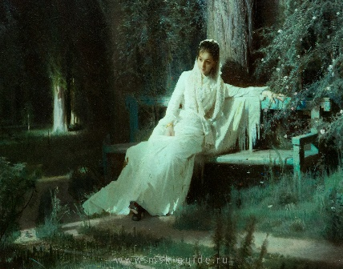 | 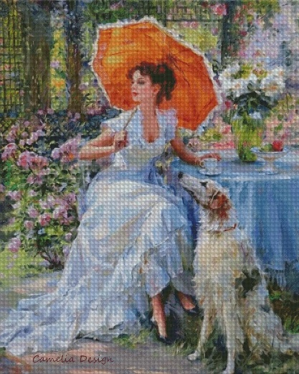
Ivan Kramskoy  "Moonlight Night" | Konstantin Razumov  "Portrait of a young girl"
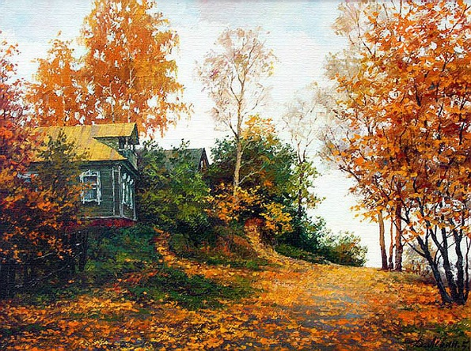 | 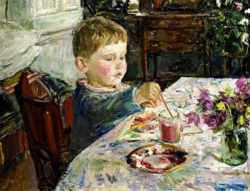
Dmitry Levin  "Autumn" | Arkady Plastov  "Young Artist"
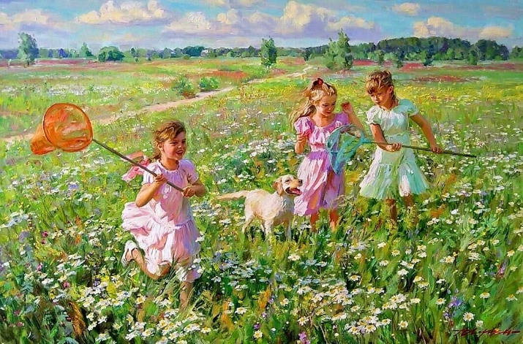 | 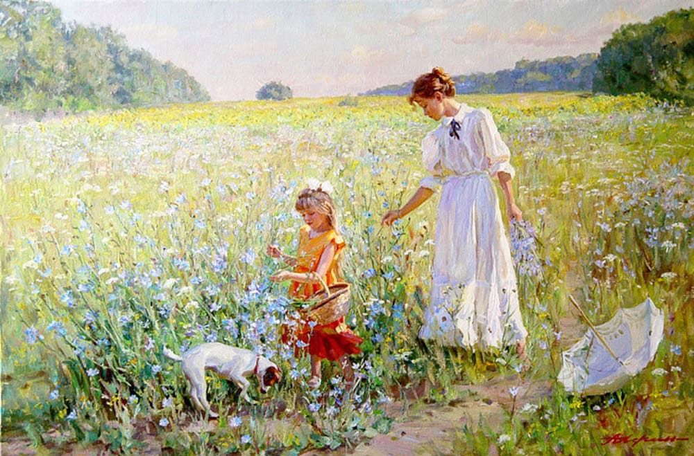
Alexander Averin  "In the meadow" | Alexander  “Wildflowers”

Exercise 14. Make up 8 sentences using these words.
an artist художник
a painter of the Russian scenery художник, изображающий
российский пейзаж
to reveal beauty отразить красоту
a poet of the Russian countryside поэт российской деревни
to develop the traditions of smth. развить традиции чего-либо
the realistic landscape school школа реалистического
пейзажа
to reflect one’s own moods передавать чьи-либо
настроения
to depict отражать, передавать
one’s brush чья-либо кисть, стиль
to transfer one’s feelings to the canvas перенести чьи-либо чувства
на холст
a master of landscape мастер пейзажа
to bring out the loneliness подчеркивать одиночество
to be greatly influenced by smb., smth. испытать сильное влияние
кого-либо, чего-либо
a subject of a canvas предмет изображения на картине
to depict the scenery изображать пейзаж
to be full of subtle feeling and tenderness быть полным нежности
truly realistic действительно реалистичный
influence over smb. влияние на кого-либо
to overestimate smth. переоценить что-либо
the love and gratitude of people любовь и благодарность людей

Exercise 15. Read and translate the text.
Isaac Ilyich Levitan, the great Russian artist, was one of the first painters of the Russian scenery to reveal its beauty. He is a real poet of the Russian countryside. Levitan developed the traditions of painters of the Russian realistic landscape school - Savrasov, Polenov, Serov and others. He found poetry in what would seem daily life.
Levitan is a very special sort of painter. There is something in his landscapes that reflects our own moods. He deeply felt what he wanted to depict, and his brush transferred his feelings to the canvas.
A master of landscape, he never introduced figures into it. Though if you look at «The Autumn Day in Sokolniki», everything seems to bring out the loneliness of the figure in the centre: the trees losing their leaves, the remote, indifferent sky, the path going off into the distance. But the fact is that it was not Levitan who painted the figure. It was Checkov’s brother Nikolai who did it.
Levitan’s art was greatly influenced by his travels along the Volga. He chose Plyoss, a small provincial town on the Volga, for his place of residence and for a subject of many of his canvases. His paintings like «Evening», «Golden Plyoss», «After the Rain» depict the scenery of the place. They are full of subtle feeling and tenderness, but there is no sentimentality in them; Levitan’s pictures are truly realistic.
In the closing years of his life Levitan made several journeys abroad. He travelled to France, Italy and Germany where he painted many of his landscapes. Levitan was only 49 when he died in 1900.
Levitan’s influence over lyrical landscape painters can’t be overestimated. His deep feeling for nature, love for his native land, his ability to reveal the poetry of the Russian countryside have won his paintings the love and gratitude of people.

Exercise 16. Read and translate the text.
Autumn Day, Sokolniki
This work, painted when Levitan was 19, was the first acquired by the patron Tretyakov. It relies on a simple but effective compositional arrangement, with the two convergent lines formed by the edges of the path meeting those of the tree-line in the centre of the canvas. The two reflecting triangles accentuate the depth of the composition and suggest the loneliness of the scene. The colours are warm, and divided into a subtle spectrum: first, the bright hues of the grass and the path, then the golden yellow of the small and younger trees, behind them the higher trees, with their brown-green leaves, and finally, the blue of the sky.
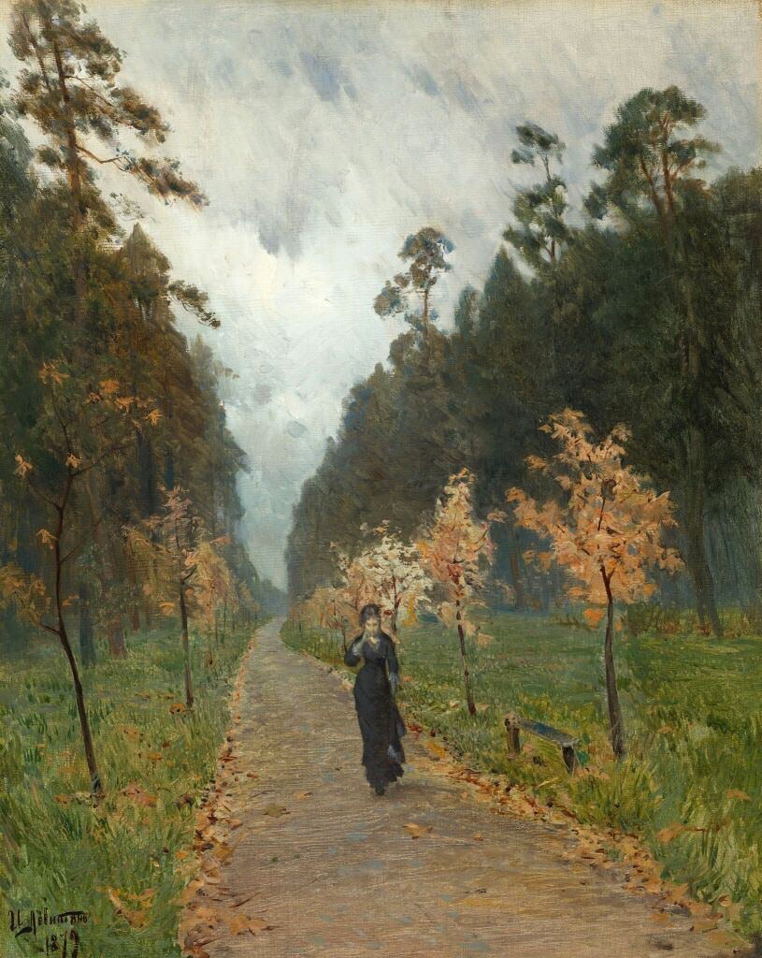
In the foreground, the lady in black captures the eye. In a sense she is the subject of the painting, yet Levitan only added her later on, on the suggestion of his friend Nikolai Chekhov, who could not conceive of a work without human figures. Throughout the preparatory process, Levitan focused on only the landscape, completing a number of drafts before finishing the canvas in the studio. In this sense, the landscape itself is the subject of the work. The viewer is struck first by the naturalism of the scene and by the scale of the trees stretching upwards to the sky. A strong emotion of sorrow is conveyed through the desolation of the setting, which would have been enhanced by the empty bench had the woman not been added.
Sokolniki is a park outside of Moscow where Levitan had settled for a time with his sister, having been expelled from Moscow as a Jew following the failed assassination attempt of Tsar Alexander II by a Jewish revolutionary. Dejected and lonely, we can imagine Levitan's feelings as he walked among the trees making sketches for this painting. The work was exhibited at a Moscow School exhibition, where it is said to have angered Levitan's mentor Savrasov, who found the woman "unnecessary". Nevertheless, the collector Tretyakov purchased the work and started to follow Levitan's career.

Exercise 17. Answer the questions:
1.What is Levitan famous for as a painter?
2.Why can he be called a very special sort of painter?
3.What genre did he paint in?
4.What was Levitan’s art greatly influenced by?
5.Why can you say that Levitan’s influence over lyrical landscape painters can’t be overestimated?

Exercise 18. Translate into English:
1.Левитан, знаменитый русский художник, считается мастером русского пейзажа.
2.Левитан, изображая пейзажи, передавал настроение.
3.Мастер пейзажа, Левитан развил традиции русской реалистической пейзажной школы.
4.Многие картины Левитана, полные нежности, но реалистичные, изображают плес.
5.Трудно переоценить влияние Левитана на русское искусство.

Exercise 19. Describe the painting "Dandelions" using the following phrases:
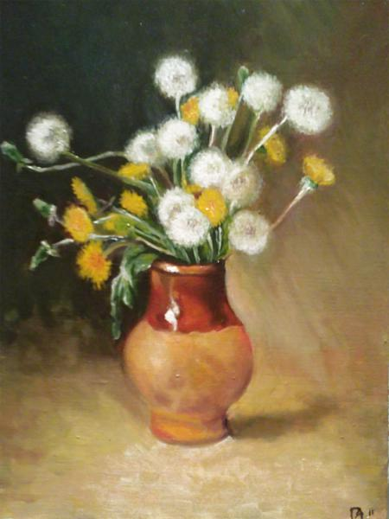
gray background
white caps
clay pot
gentle, clear and airy
unopened buds
a shadow falling
In the foreground
on the back ground
It feels like складывается ощущение
dark night outside the window
She exudes warmth, summer, calm and peace. От картины веет теплом лета, покоем и умиротворением
changed into little white airy dresses переоделись в белые, воздушные платья

Exercise 20. Read and translate the text.
Master of Marine Art
Ivan Aivazovsky was one of Russia's greatest painters, known worldwide for his breath-taking marine landscapes. Born in 1817 in Feodosia, Crimea, he had a unique talent for capturing the beauty and power of the sea. His paintings often depicted stormy seas, calm waters, and dramatic shipwrecks, immortalizing moments of both tranquillity and chaos.
Aivazovsky began painting at a young age and quickly developed a passion for art. His early works showed great promise, leading him to study at the Imperial Academy of Arts in St. Petersburg. There, he honed his skills under renowned artists and soon became recognized for his exceptional ability to portray water and light.
Throughout his career, Aivazovsky created thousands of paintings, many of which focused on maritime themes. He travelled extensively, drawing inspiration from the shores of Europe, Asia, and Africa. His attention to detail and ability to convey emotion through colour and composition made his works stand out among contemporaries.
One of Aivazovsky's most famous paintings is «The Ninth Wave», completed in 1850. This masterpiece captures the terrifying yet awe-inspiring force of nature. Set in the aftermath of a fierce storm, the painting shows survivors clinging to debris, surrounded by towering waves. The sky is dark and ominous, contrasting sharply with the white foam of the breaking waves. Light filters through the clouds, casting a hopeful glow on the desperate figures below.
«The Ninth Wave» reflects Aivazovsky's deep fascination with the sea's dual nature—as both a source of life and a destructive force. The painting invites viewers to contemplate humanity's struggle against the elements, evoking feelings of fear, admiration, and resilience.
In addition to his artistic achievements, Aivazovsky was also a generous philanthropist. He used his wealth and influence to support cultural initiatives in his hometown, including the establishment of an art school and public gallery. Today, his legacy lives on not only through his stunning paintings but also through the opportunities he provided for future generations of artists.
To appreciate Ivan Aivazovsky's genius fully, one must experience his works in person. His brushstrokes bring the sea to life, transporting viewers to distant shores and turbulent waters. Whether depicting calm sunsets or raging storms, Aivazovsky remains unparalleled in his ability to capture the essence of the maritime world.

Exercise 21. Read the following statements and decide whether you agree or disagree with them. Use phrases like "I agree because..." or "I disagree because...".

- Ivan Aivazovsky was born in Moscow.
- He studied at the Imperial Academy of Arts in St. Petersburg.
- Aivazovsky painted mostly landscapes with mountains.
- «The Ninth Wave» shows people celebrating on a beach.
- Aivazovsky supported cultural initiatives in his hometown.
- He created thousands of paintings throughout his career.
- «The Ninth Wave» depicts a calm sea after a storm.
- Aivazovsky used bright colours to convey hope in his paintings.
- He never travelled outside Russia for inspiration.
- His paintings mainly focused on peaceful scenes of nature.

Exercise 22. Create short dialogues (4-5 exchanges) using vocabulary related to Ivan Aivazovsky and his artwork. Here are some prompts to get started:
- Discussing a visit to an art museum where Aivazovsky's paintings are exhibited.
- Comparing Aivazovsky's style with another artist's style.
- Talking about the emotions evoked by «The Ninth Wave».
- Debating whether Aivazovsky's contributions were more significant as an artist or as a philanthropist.

Exercise 23. Read and translate the text.
I’m a specialist in advertising from Magnitogorsk Pushkin drama theatre. We are pleased to inform you that a new performance “Groza” the Laureate [lo:riət] of the National theatre award “The golden mask” will be presented on the stage of your theatre soon. “Groza” is staged by a talented director Lev Arenburg who tries to get away from standards of the classical play. He showed the problems of people of a small provincial town as he is interested in the "living life" but he did it in an unusual, even shocking way. His vision is quite different from what you can expect.
Here, all victims of circumstances suffer. They are not satisfied with their life, but they cannot do anything to turn it for the best. Katerina is married to a mama’s boy Tikhon. Kabanikha (the worst mother-in-law ever) destroyed their relationship. As a result, Katerina has a love affair with Boris, a young man, whose uncle controls his inheritance... Her feeling of guilt and despair poisons her life and makes her put an end to it. So, she commits suicide to escape her miserable and unbearable life.
This performance contains a lot of life, a lot of expression and a lot of acting. The play evokes strong emotions: either irritation or anger, or passion and tenderness, almost Christian charity. Arenburg staged a very Russian performance because of mysterious Russian soul.
The excellent cast helps him: the professional acting by Lavrova Nadezhda, Bogdanov Vladimir, Brazhenkov Evgeniy, Dashuk Anna and other actors. The dark scenery and unusual costumes help to reflect the atmosphere of the place. There are no special effects or soundtracks. The music just helps to express the feelings of the characters.
Arenburg’s “Groza” gives you food for thought. You may dislike it but it will not leave you indifferent. I strongly recommend you to see it because the message of the play is very inspiring. You can do it on the 18th of October, on Sunday at 6 p.m. For those who are looking for best viewing seats, you can go for Stall section which is nearest to the stage. Central seats in the middle of the Stalls are ideal, too. We offer discounted tickets for disabled people, groups of students and organizations.
You can find us in 66 Lenin Avenue. You can get there easily by bus, by tram or by taxi. You can book seats beforehand. There are some age restrictions. It is recommended to young people of 18 and older.
Don’t miss it!

Exercise 24. Are the statements true, false or not stated? Explain.
1. The performance "Groza" has already won the National theatre award.
2. Katerina's relationship with Tikhon was destroyed by her own actions, not by Kabanikha.
3. Arenburg's performance reflects the essence of the Russian soul.
4. The performance uses bright colours and traditional costumes.
5. The music is the main focus of the performance.
6. Arenburg's "Groza" makes you think deeply.
7. The theatre is located in a remote area.
8. Seats cannot be booked in advance.
9. The performance is recommended for individuals aged 18 and above.
10. It is not worth watching the performance.

Exercise 25. Answer the questions:
1. What is the new performance "Groza" about?
2. How does director Lev Arenburg approach the staging of "Groza" differently from classical plays?
3. Why does Katerina have a love affair with Boris in the play?
4. How does Katerina's feeling of guilt and despair affect her actions in the performance?
5. What emotions does the play "Groza" evoke in the audience, according to the text?
6. How does the cast contribute to the overall atmosphere of the performance?
7. What message does the author believe the play "Groza" conveys to its viewers?

Exercise 26. You have received an email message from your English-speaking pen-friend Greg:
From: Greg@mail.uk
To: Russian_friend@mail.ru
Subject: music
...After 5 years of waiting, I finally saw my favourite band perform live for the first time. It was a wonderful show and an unforgettable experience. What are your favourite bands? Have you ever been to their concerts? What musician or singer would you most like to meet? Why?

Write an email to Greg.
In your message:
- answer his questions;
- write 100-140 words.
Remember the rules of email writing.

Тема 2.3

Технический прогресс: перспективы и последствия. Современные средства связи

Exercise 1. Study the active vocabulary and make up 8 sentences.

age  annual  atomic  available  consequence  copy  correct  crime  decade  document  e-mail (electronic mail)  enemy  enter  good  impossible  influence | век  ежегодный  атомный  доступный  следствие  копия  исправлять  преступление  десятилетие  документ  электронная почта  враг  вводить, входить  добро  невозможный  влияние, влиять | lord  occur  periphery  photo album  progress  realistic  relative  report  simplify  slave  social  tear (oneself) away  ticket  type  typewriter  virtual | господин  возникать  периферия  фотоальбом  прогресс  реалистичный  родственник  отчет  облегчать  раб  социальный  оторвать (ся)  билет  печатать  печатная машинка  виртуальный

Exercise 2. Read the text The role of technical progress.
The scientific and technical revolution has changed our life very much. The computers, the mobile phones and other digital devices have entered our everyday life.
The atomic, space and energy age was followed by the age of computers. The tasks which had seemed eternal before have been solved one by one by computers. During the last decade, many fundamental changes occurred because of electronic devices. It is even difficult to imagine the social and economic consequences of the microelectronic revolution.
The large use of computers has influenced our life in such а way that it was difficult to imagine 15 or 20 years ago. On the one hand, computers have simplified our life greatly. If you typed а text on the typewriter and made а mistake you had to type the whole page again. Making several copies of the same document used to be а difficult job too. But now it's quite different. Correcting mistakes is easy. Computer also helps us to buy goods, find information, book tickets, make presentations and annual reports, and make difficult calculations. Time is saved for leisure.
Leisure time is also influenced by computer and other periphery devices. You no longer go to the music shops - many things are available on the internet. You needn't write letters to your relatives or friends - you can send an e-mail. And your photo albums are on computer too.
Computer games are probably also а part of your free time. They became more and more realistic and complicated, and for many people it becomes impossible to tear themselves away. This means that electronic devices, such as computer and ТV set are used mostly for entertainment and consume most of the time that could be spent on work, going for а walk and sleeping. Man becomes а slave of the devices, which were designed to make him stronger.
Is there а way out? In fact, there is, but many people don't know it and are still slaves. The best decision is not to give these pieces of equipment place in your heart. They should do their work. And when you have а rest, prefer real communication to virtual one and living an active life to watching films about crime. Then electronics will be not our lord or enemy but our friend!

Exercise 3. Answer the following questions to the text.
1. The technical revolution has changed our life very much, hasn't it?
2. What were the predecessors of computer age?
3. Do computers make our life easier and simpler? In what way?
4. Computers influence our free time too, don't they?
5. Can you get music and video on the Internet? What other information can you get there?
6. What devices became compatible with computer during the last years?
7. Can you communicate with your friends on the Internet? Do you like such communication or you prefer real one?
8. In what way do computer games influence the people?
9. Do electronic devices take all our free time?
10. Is man а slave of the devices, which were designed to make him stronger?
11. Does the author suggest а way out?
12. What is the way out in your opinion?

Exercise 4. Study the Active vocabulary. Insert the missing words.
1. ___ helps you to send letters quickly.
2. If there is an interesting program on ТV, it's difficult for а person to ___.
3. During the last two ___ scientific progress and digitization took place.
4. For some people а computer is an equivalent of а ___: а device for printing and editing documents.
5. Do you have many ___? - Yes, I have parents, grandparents, two sisters and three brothers.
6. 1 don't buy ___ any more, all my photos are on my computer.
7. Computer is а multifunctional device. So the ___ is that it can be used both for work and for leisure.
8. ___ age was followed by а microelectronic one.

Exercise 5. Continue the following statements.
1. The atomic, space and energy age was followed by ...
2. It's difficult to imagine the social and economic consequences ...
3. Computers have simplified ...
4. Computer helps us to buy goods, find information ...
5. Leisure time is also influenced ...
6. You no longer go to the music shops ...
7. You needn't write letters to your relatives ...
8. Computer and ТV set are used mostly for entertainment ...
9. The best decision is not to give these pieces of equipment...
10. When you have а rest, prefer real communication ...

Exercise 6. Write an essay on one of the following topics.
1. Computer and leisure time.
2. Man: а slave or а master of electronic devices.
3. Electronic slavery: is there а way out?

Exercise 7. Read and translate the text.
Internet Security
In this modern era, where nearly everything we do is linked to the internet, maintaining online security has become increasingly vital. As cyber threats like hacking, phishing, malware, and identity theft continue to rise, understanding the fundamentals of internet security and taking proactive steps to defend ourselves is paramount.
Cyber threats encompass a variety of malicious activities aimed at compromising digital systems and stealing valuable information. These threats include malware, which refers to harmful software designed to cause disruption or damage to computers. Common examples of malware are viruses, worms, Trojans, and ransomware. Another prevalent threat is phishing, where fraudsters attempt to deceive people into revealing sensitive data such as login credentials or banking details by posing as legitimate entities. Identity theft occurs when someone assumes another person's identity, typically for financial gain. Denial-of-service (DoS) attacks seek to render machines or networks unusable by overwhelming them with excessive traffic.
To fortify your online defences, consider adopting several best practices. First, create strong, unique passwords for each of your accounts. Steer clear of obvious choices like “123456” or “password”, and leverage password managers to help generate and securely store complex passwords. Enable two-factor authentication (2FA) whenever possible, adding an extra layer of security by requiring a secondary verification method, often a code sent to your mobile device, in addition to your password.
Regularly updating your operating system, web browsers, and applications is crucial, as outdated software may contain vulnerabilities that hackers can exploit. Exercise caution when using public Wi-Fi networks, avoiding sensitive transactions unless absolutely necessary. If you must connect, utilize a virtual private network (VPN) to encrypt your data and maintain privacy. Always be wary of suspicious emails, messages, or links requesting personal information, verifying the sender's legitimacy before engaging.
Installing reliable antivirus software is another effective measure against malware. Ensure real-time protection is active and perform routine scans to identify and eliminate potential threats. Backing up your important files regularly to external drives or cloud storage can help minimize the impact of ransomware attacks or hardware failures. Lastly, stay informed about emerging cybersecurity trends and threats to bolster your ability to recognize and thwart new forms of attack.
Businesses face heightened risks due to the volume and sensitivity of the data they handle. In addition to the previously mentioned practices, companies should prioritize employee training to educate staff on proper internet security protocols, including identifying phishing scams and managing confidential data. Robust network security measures, such as firewalls, intrusion detection systems, and access controls, are essential to safeguard corporate networks. Encrypting sensitive data both at rest and during transmission prevents unauthorized access. Finally, developing a comprehensive incident response plan ensures swift and effective action in the event of a cyberattack.
Good internet security habits are indispensable in today's interconnected society. By adhering to these recommendations and remaining alert, individuals and organizations can significantly lower the likelihood of becoming victims of cybercrime. Remember, prevention is far preferable to dealing with the aftermath of a breach when it comes to online safety.

Exercise 8. Answer the following questions based on the information from the text:
1. Why is internet security important in today's digital age?
2. Define what malware is and provide examples.
3. Explain what phishing is and how it works.
4. What is identity theft, and why is it dangerous?
5. Describe a denial-of-service (DoS) attack and its purpose.
6. What are some best practices for creating strong passwords?
7. What is two-factor authentication (2FA), and how does it enhance security?
8. Why is it important to keep software updated?
9. What precautions should you take when using public Wi-Fi?
10. How can backing up your data help in case of a ransomware attack?

Exercise 9. Decide whether each statement is true or false according to the information given in the text:
1. Using simple passwords like “123456” is recommended for easy memorization.
2. Two-factor authentication requires only a single form of verification.
3. Outdated software never contains security vulnerabilities.
4. It's safe to access sensitive information on public Wi-Fi without a VPN.
5. Installing antivirus software guarantees complete protection against all types of malware.
6. Ransomware attacks can be mitigated by regularly backing up data.
7. Employee training on cybersecurity is unnecessary if the business already has strong technical protections.
8. Encrypting data provides no additional security benefits.
9. Developing an incident response plan is only necessary after a cyberattack occurs.
10. Maintaining good internet security habits is less important than reacting to breaches.

Exercise 10. Match the words from the text with their definitions:
- Malware  - Phishing  - Identity Theft  - DoS Attack  - Two-Factor Authentication  - Antivirus Software  - Incident Response Plan  - Encryption | - Programs designed to detect and remove malware.  - Flooding a network or server with excessive traffic to make it unavailable.  - Assuming another person’s identity for personal gain.  - The process of converting data into a coded format to prevent unauthorized access.  - Requiring a second form of verification in addition to a password.  - Obtaining sensitive information through deception.  - A detailed strategy for responding to cybersecurity incidents.  - Harmful software designed to damage or disrupt computer systems.

Exercise 11. Review the words. Can you translate them?
desktop  laptop  tablet  server  printer  router | to boot up  to shut down  hard drive  memory  graphics card  power supply | wireless adapter  touch screen  out of date  user-friendly  piece of cake

Exercise 12. Spot the target words in these sentences.

1. I have a desktop computer at home, but I prefer my laptop for on-the-go work.
2. My laptop is light and portable; I can take it anywhere.
3. She uses a tablet to read books and watch videos.
4. The server is responsible for storing and sharing data between computers.
5. The printer was out of ink, so I had to replace the cartridge.
6. A router connects all the devices in a network together.
7. To boot up a computer, press the power button and wait a few seconds.
8. Make sure to shut down your computer properly before turning it off.
9. I had to replace my hard drive because it stopped working.
10. My computer's memory was full, so I deleted some files to free up space.
11. A good graphics card is important for playing video games.
12. The power supply provides electricity to keep the computer running.
13. He bought a wireless adapter to connect his computer to the internet without wires.
14. The tablet has a touch screen that responds to finger taps.
15. My phone is out of date and doesn't support the latest apps.
16. This software is user-friendly and easy to use even for beginners.
17. Cooking this recipe is a piece of cake; it's very simple.

Exercise 13. Match these words to their definitions.

Definitions: | Words:
a. A computer system that provides data or services to other computers or devices on a network.  b. An expansion card installed inside a computer that enables it to display high-quality graphics and video.  c. A device that allows a computer to connect to a wireless network without using cables or wires.  d. A mobile device with a touch screen display, typically smaller than a laptop but larger than a smartphone.  e. A display screen that responds to touch input, allowing users to interact with the device by tapping or swiping their fingers on the screen.  f. A portable computer that can be easily carried around and used in different locations.  g. Easy to use or understand, especially for someone who is not familiar with technology.  h. The primary storage device for a computer, which stores all software programs and user files.  i. A networking device that forwards data packets between computer networks.  j. A machine that produces printed copies of documents or images stored in electronic form.  k. To turn off a computer or other electronic device in an orderly manner.  l. To start a computer by loading the operating system into its memory from a hard disk or other storage device.  m. Something that is very easy to do or accomplish.  n. A component of a computer that converts AC power from an electrical outlet into DC power that can be used by the computer's internal components.  o. No longer current or applicable; obsolete.  p. The part of a computer that temporarily stores data while it is being processed or accessed.  q. A computer designed to be used on a desk or table, typically consisting of a monitor, keyboard, and CPU. | 1. power supply  2. piece of cake  3. hard drive  4. tablet  5. laptop  6. out of date  7. server  8. printer  9. memory  10. router  11. to boot up  12. touch screen  13. to shut down  14. desktop  15. user-friendly  16. wireless adapter  17. graphics card

Exercise 14. Match these words to their translation.
- smartphone  - touch screen  - mobile data  - download  - science  - screen  - upload  - device  - app  - tablet  - text message  - natural sciences  - social sciences | - экран  - Наука  - естественные науки  - мобильные данные  - текстовое сообщение  - скачать  - планшет  - общественные науки, социология  - устройство  - сенсорный экран  - приложение  - загрузить (выложить на сайт, в сеть)  - смартфон

Exercise 15. Раскройте скобки, употребляя глаголы в Present, Past или Future Simple Passive.
- Bread (to eat) every day.
- The letter (to receive) yesterday.
- Nick (to send) to Moscow next week.
- I (to ask) at the lesson yesterday.
- I (to give) a very interesting book at the library last Friday.
- Many houses (to build) in our town every year.
- This work (to do) tomorrow.
- This text (to translate) at the last lesson.
- These trees (to plant) last autumn.
- Many interesting games always (to play) at our PT lessons.
- This bone (to give) to my dog tomorrow.
- We (to invite) to a concert last Saturday.

Exercise 16. You have received an email message from your English-speaking pen-friend Margaret:
From: Margaret@mail.uk
To: Russian_friend@mail.ru
Subject: e-learning
I'm doing a school project on e-learning. What's your attitude to online learning? Do you prefer classes online or in a traditional classroom? Why? Do you think e-learning can be effective for all subjects?

Write an email to Margaret.
In your message:
- answer her questions;
- write 100-140 words.
Remember the rules of email writing.

Тема 2.4

Выдающиеся люди родной страны и страны/стран изучаемого языка, их вклад в науку и мировую культуру

Exercise 1. Read and translate the text.
In recent years, scientific and technological developments have drastically changed life on our planet as well as our views both of ourselves as individuals in society and of entire Universe as a whole.
Today, science and technology are closely related. Many modern technologies such as nuclear power and space flights depend on science and the application of scientific knowledge and principles. Each advance in pure science creates new opportunities for the development of new ways of making things to be used in daily life. In turn, technology provides science with new and more accurate instruments for its investigation and research.
Technology refers to the ways in which people use discoveries to satisfy needs and desires, to alter the environment, to improve their lives. Throughout human history, men and women have invented tools, machines, materials and techniques, to make their lives easier.
Of course, when we speak of technology today, we are looking at it in a much narrower sense. Generally, we mean industrial technology, or the technology that began about 200 years ago with the development of power-driven machines, growth of the factory system, and mass production of goods that has created the basis for our modern society. Today we often say that we live in an age of science and technology. According to one estimate, 90 % of all the scientists who ever lived, were alive and active in the 1970-s. This increased scientific activity has brought new ideas, processes, and inventions in ever-growing amount.
The scientific revolution that began in the 16th century was the first time that science and technology began to work together. Thus, Galileo, who made revolutionary discoveries in astronomy and physics, also built an improved telescope and patented a system of lifting water. However, it was not until the 19th century that technology truly was based on science and inventors began to build on the work of scientists. For example, Thomas Edison built on the early experiments of Faraday and Henry in his invention of the first practical system of electrical lighting. So too, Edison carried on his investigations until he found the carbon filament for the electric bulb in a research laboratory. This was the first true modern technological research.
In a sense, the history of science and technology is the history of all humankind.

Exercise 2. Choose the right answer.
1. Which of the following sentences best describes the main idea contained in the text?
(A) Technical progress does not depend on scientific discoveries;
(B) Scientific inventions did not influence the history of all humankind;
(C) In modern world science and technology are interdependent;
(D). Industrial technology hasn’t created the basis for our modern society.
2. Which of the following is true?
(A) Faraday found the filament for the electric bulb.
(B) Galileo carried out the first true modern technological research.
(C) Science and technology are not related at all.
(D) The scientific revolution of the 16th century was the time when science and technology began to work together.
3. Science and technology are related because:
(A). modern technologies depend on science and the application of scientific knowledge and principles.
(B). scientists benefit from introducing new technologies.
(C). Galileo made revolutionary discoveries in astronomy and physics.
(D). the scientific revolution began in the 16th century.

Exercise 3. Подберите из списка В английские эквиваленты к словам из списка А.
А. наука, эпоха, открытие, изобретение, утверждение, достижение, исследование, вклад, цель, оборудование, эффективность, значение.
В. achievement, discovery, investigation, importance, purpose, epoch, contribution, science, invention, efficiency, facilities, statement.

Exercise 4. Сгруппируйте слова из списков А и В в синонимичные пары и переведите их.
- technology, to create, energy, astronaut, space, satellite, research, technique, facilities.
- exploration, cosmos, method, sputnik, apparatus, to make, cosmonaut, power, engineering.

Exercise 5. Read and translate the text.
Alexander Popov was a Russian scientist and inventor. He was born in 1859 in Turinskiy, Russia and died in St Petersburg in 1906. Alexander Popov studied physics at the University of St Petersburg and then he became a professor there. He invented one of the first radios in the world. In 1895, he demonstrated his radio for the first time. At this time, Guglielmo Marconi was also working on his own radio. Many people think that Marconi invented the radio, but it's not true. Marconi and Popov both invented their radios independently of each other. Popov's radio was very important because it was the first radio that could send messages over long distances. In 1896, Popov sent the first radio message in the world. He sent the message from his radio in his laboratory to a radio receiver on a boat in the Baltic Sea. The message was 'Heinrich Hertz' - Hertz was another famous scientist who worked on radio waves. Popov's radio was the beginning of wireless communication. The Internet, mobile phones, and television are all possible because of radio and wireless communication.
Ivan Pavlov was a Russian physiologist and psychologist. He was born in Ryazan in 1849 and died in Leningrad in 1936. Ivan Pavlov studied medicine at the University of St Petersburg and then he went to Germany to study with Carl Ludwig. In 1890, Pavlov returned to St Petersburg and he became professor of pharmacology at the university. In 1904, he won the Nobel Prize for Physiology or Medicine for his work on the physiology of digestion. But Pavlov is most famous for his work on conditioned reflexes. The best-known experiment is the one with dogs. Pavlov put food in front of the dogs and they started to salivate (produce saliva). Then he rang a bell every time he gave the dogs food. After a while, the dogs started to salivate when they heard the bell, even if there was no food. This is called a conditioned reflex. It means that the dogs learned to connect the sound of the bell with the food and so their bodies produced saliva. Pavlov's experiments on dogs were very important for our understanding of human psychology. They showed that animals and humans learn things by making connections between different events.
Vladimir Zworykin was a Russian-American inventor, engineer, and pioneer of television technology. He was born in Murom, Russia in 1888 and died in Princeton, New Jersey in 1982. Zworykin studied physics and engineering at the St Petersburg Institute of Technology. In 1919, he went to the United States and worked for Westinghouse Electric Corporation. Later, he worked for the Radio Corporation of America (RCA) for many years. Zworykin invented a lot of new technologies. One of his most famous inventions is the iconoscope, which is an electronic image scanner. The iconoscope was the first practical television camera and it was used in the first television systems. In 1931, Zworykin demonstrated his television system to the public for the first time. His television system was very important because it made television possible. Television has changed our lives and it's one of the most important inventions of the twentieth century. We can watch news, sport, and entertainment from all over the world. We can see and learn about other cultures. And we can watch important events like the Olympic Games and the World Cup.

Exercise 6. Are these statements true or false? Correct the false ones.
1. Alexander Popov was a scientist and inventor from Russia.
2. In 1896, he demonstrated his radio for the first time.
3. Popov's radio was not important because it could only send messages over short distances.
4. In 1895, Popov sent the first radio message in the world.
5. Ivan Pavlov was a physiologist and psychologist from Russia.
6. In 1905, he won the Nobel Prize for Physiology or Medicine for his work on the physiology of digestion.
7. Zworykin studied physics and engineering at the Institute of Technology in St Petersburg.

Exercise 7. Choose the right answer:
1. What was Alexander Popov's most important invention?
A. The television
B. The radio
C. The computer
D. The mobile phone
2. When did Alexander Popov demonstrate his radio for the first time?
A. In 1859
B. In 1895
C. In 1906
D. In 1896
3. Who was the other scientist working on radio at the same time as Popov?
A. Carl Ludwig
B. Heinrich Hertz
C. Guglielmo Marconi
D. Ivan Pavlov
4. What did Pavlov's experiment with dogs show?
A. That dogs can be trained to do tricks
B. That dogs have a good sense of smell
C. That dogs can learn to connect a sound with food
D. That dogs are very intelligent animals
5. What is one of the most important things we can do with television?
A. Communicate with people
B. Watch news and entertainment
C. Learn about other cultures
D. All of the above

Exercise 8. Learn the words.
https://quizlet.com/ru/1109433479/science-flash-cards/?i=3jsah5&x=1qqt

Exercise 9. Переведите предложения на английский язык, используя формы активного залога.
Present Simple
1. Мы полагаем, что эта работа российских физиков займет свое должное место среди важнейших открытий. 2. Ни один из этих факторов не участвует в данном процессе. 3. Все эти факторы приводят к снижению эффективности исследовательской работы и к увеличению сроков проведения отдельных исследований. 4. Ученые не только изучают современный мир, но и делают предсказания о его дальнейшем развитии. 5. В его статье обсуждаются новые данные. 6. Никакого объяснения этих результатов в статье не представлено. 7. В этой работе описаны результаты экспериментальных наблюдений.
Present Perfect
1. За последние двадцать лет отдельные направления в науке развились в самостоятельные отрасли знаний. 2. До сих пор нам не удалось полностью понять природу этого явления. . 3. В настоящее время исследование еще не закончено. 4. За последние десятилетия данная наука добилась огромных успехов. 5. В последние годы мы были свидетелями значительного прогресса во многих областях знаний. 6. В последние годы значительно улучшились условия для развития научных контактов. 7. Мы еще не закончили эти исследования.
Past Simple
1. Исаак Ньютон сформулировал три теперь хорошо известных закона. 2. Эйнштейн опубликовал свою первую статью в 1905 г. 3. В статье профессора N не содержалось никаких новых экспериментальных данных. 4. Председатель представил основных докладчиков.
Present Continuous
1. Ученые сейчас решают большое число проблем, которые непосредственно не связаны с производством. 2. В наши дни объем научной информации растет очень быстро. 3. Научные контакты в различных областях исследований быстро расширяются. 4. Сейчас происходят большие изменения в организации научной работы. 5. Роль науки в жизни общества возрастает.

Exercise 10. Вставьте правильную форму глагола времени Present Perfect, Past Simple или Present Simple в действительном или страдательном залоге.
1. The role of blood clots in heart attack (not yet determine). But since a clot (block) blood flow to a part of the heart muscle, thereby killing it, researchers hope that removing a clot within the first hour will (resupply) the area with blood. 2. The outer surfaces of large meteorites (melt) rapidly. After passing air streams (sweep) this liquid rock away, a new cool layer of material (expose). The molten liquid (create) the blazing trail which (see) from thе earth. 3. The earth's internal forces of uplift are more active in the western U.S. than in the eastern part. Eruptions (occur) in this area for centuries. Mount St. Helens (erupt) in 1980. The Baldwin Hills area of the Los Angeles Plain (steadily push) forward at the rate of three feet every 100 years. There (be) also constant slipping along the San Andreas fault. 4. Although man (climb) the highest mountain and (probe) the depths of the ocean, no one (find) sufficient evidence to identify the famous Loch Ness monster in Scotland. However, some researchers (believe) that the "monster" (be) simply pine logs which (fall) into the deep lakes and (decay) producing gas bubbles which (seal) by the pine resin. Eventually, the logs (become) buoyant, and they (float) to the surface. 5. Not only numbers but all characters (code) in binary when they (transmit) to the computer. The machine (give) a list of equivalent expressions to represent these symbols. The central processing unit (design) to recognize these binary numbers. The programmer, however, (must organize) and (separate) the information the computer needs and the instructions it (must execute) in order to obtain accurate results for the program. 6. Paleontologists (discover) what (believe) to be the oldest form of life on earth. Life, in the form of bacterial cells, (exist) 3.5 billion years ago, only one billion years after the earth (form). The fossilized bacteria (discover) by examining old sedimentary rocks (find) in Australia. About five different forms of bacteria (identify) that are almost identical to their modern-day cousins. The discovery (push) back the origin of life 1.2 billion years earlier than (previously think). 7. When a solution of dichromate and sulphuric acid (drip) into boiling ethyl alcohol, acetaldehyde (form) in a medium whose temperature is 60 degrees above its boiling point. For this reason, the acetaldehyde (escape) before the greater part of it (undergo) oxidation. The reaction (carry out) under a fractionating column that (allow) the aldehyde to pass but (return) the alcohol to the reaction vessel.

Exercise 11. Заполните пропуски, используя соответствующую форму глагола времени Past Simple, Past Continuous или Past Perfect в действительном или страдательном залоге.
The Discovery of Penicillin
Alexander Fleming, a Scottish research bacteriologist, (study) the deadly staphylococcus when he (make) _ his famous discovery in 1928. For examination purposes, Fleming (remove) _ the cover of the bacteria culture with which he (work_ A mold (form) _ on the exposed culture. Fleming (notice) _ that in the area surrounding the mold, the staphylococci (disappear) _. He (keep) _ a strain of the mold alive and (begin) _ testing it on laboratory animals. In 1929, he (publish) _ his first medical paper in which he (prove) _ that a simple soil mold (be) _ a powerful microbe killer that (not injure) _ human tissue. For years, chemists (be unable) _ to extract enough pure concentrated penicillin to use in medicine. Then in 1938, a team of Oxford scientists (remember) _ the research paper of nine years earlier. They ultimately (succeed in) _ developing a method for mass-producing penicillin.

Exercise 12. Read the article “23 Russian inventions, the modern world can`t live without” by A. Chereshneva and fill in the table.
https://porusski.me/2023/07/06/12-23-russian-inventions/

RUSSIAN INVENTORS AND THEIR INVENTIONS
№ | Name, surname | Inventions | Date of invention (if it is known) | Notes 1
1
2

Exercise 13. Match the inventors and their inventions.
https://learningapps.org/view19424272

Exercise 14. Speak about the most amazing Russian invention and its inventor (8-12 sentences). Use the following:
I'm going to talk / speak about ...
That's all I wanted to say.
Thank you for your attention.

Exercise 15. Read and translate the text.
Steve Jobs was an American businessman, inventor and industrial designer. He was born on 24 February 1955 and died on 5 October 2011.
Jobs is most famous for being one of the co-founders of Apple Inc., along with Steve Wozniak and Ronald Wayne. He worked at Apple from its beginning in 1976 to 1985. Then he left and started two new companies: NeXT Computer and Pixar Animation Studios. In 1997 Apple bought NeXT and Jobs returned to work there as CEO (chief executive officer). Apple then became very successful with products like the smart phone, laptop and computer.
Bill Gates is an American businessman and computer programmer. He was born on 28 October 1955. Gates is most famous for being the co-founder of Microsoft Corporation, along with Paul Allen. He was also the chairman of Microsoft from 1980 until 2014, when he stepped down as chairman but continued to work for the company as a technology adviser.
Gates is one of the richest people in the world. He has written several books and has given a lot of money to charity. Some people say that his work has changed the world. In 2000 he and his wife Melinda set up the Bill & Melinda Gates Foundation, which gives money to help people all over the world.
Tim Berners-Lee is a British scientist and computer programmer. He was born on 8 June 1955. Berners-Lee is most famous for inventing the World Wide Web, which is what we use on the internet to look at websites, send emails, etc.
He wrote the first web browser in 1990 while working at CERN, the European Particle Physics Laboratory in Switzerland. He also wrote the first web server software. Today, more than 3 billion people use the telecommunication technology. Berners-Lee has received many awards for his work, including a knighthood from Queen Elizabeth II.
Elon Musk is a businessman and inventor. He was born on 28 June 1971 in South Africa. Musk moved to the US in 2002 and became an American citizen in 2007. He is the CEO of SpaceX, Tesla Inc., Neuralink and The Boring Company.
He is also the founder of PayPal. Musk started SpaceX in 2002 because he wanted to send humans to live on other planets. In 2008 Tesla released the first electric car that could go more than 320 km (200 miles) on one charge. Musk is very interested in renewable energy, and he thinks that we should stop using fossil fuels as soon as possible. He wants to make solar power cheaper and easier to use for everyone.
Nikola Tesla was an inventor and electrical engineer. He was born on 10 July 1856 in what is now Croatia, and he died on 7 January 1943 in New York City, USA. Tesla worked for the phone company in Budapest and Paris before moving to the US in 1884. There he worked for Thomas Edison's company, which later became General Electric.
Tesla invented a lot of things, but today he is most famous for developing alternating current (AC), which is the system we use to generate and distribute telecommunication electricity today. He also did important work in wireless telecommunication and radio waves, and he invented the Tesla coil, which is still used in telecommunication technology today. Some people think that Tesla was one of the most important inventors in history.

Exercise 16. Speak about the most amazing English or American invention and its inventor (8-12 sentences). Use the following:
I'm going to talk / speak about ...
That's all I wanted to say.
Thank you for your attention.

Exercise 17. You have received an email message from your English-speaking pen-friend Nora:
From: Nora@mail.uk
To: Russian_friend@mail.ru
Subject: Russian scientists
... Last weekend, I visited the Science Museum in London, and it was really inspiring. I'm really into science and want to learn more about scientists from Russia. What fields of science are Russian scientists most famous for? What do you think are the greatest examples of scientific success in Russian history? Is there a Russian scientist you admire the most? Why?

Write an email to Nora.
In your message:
- answer her questions;
- write 100-140 words.
Remember the rules of email writing.

Тема 2.5

Деловое общение

Exercise 1. Read and translate the text.
Public Presentations
If you're scared of public presentations, don't worry. You are not alone. Many people feel the same way. But with a little practice, you can learn to be more confident when you speak in public.
Do your homework
Before your presentation, do some research. Find out as much as you can about the subject. Make sure you know what you want to say. Write down a few notes and practise saying them out loud. Don't try to learn everything word for word, but make sure you understand the main points.
Prepare your presentation
Think about how long you will speak for. Most people speak too quickly in public. So remember to slow down. Practise speaking clearly so that everyone can hear you. And don't forget to breathe! It's important to take regular breaks and give your audience time to think.
Use your voice
When you speak in public, it's important to use your voice well. Try to speak louder than usual. Stand up straight and look at your audience. Use your hands to help explain your ideas. And remember to smile! If you are nervous, it is normal to speak more quietly. But this makes it difficult for people to hear you. So take a deep breath and try to relax.
Use visual aids
Visual aids like slides can help your audience understand your presentation. But they can also be distracting. So don't use too many. And make sure they are easy to read. Use short sentences and simple language. And don't put too much information on each slide. Remember, the most important thing is what you say, not what is on the screen.
Interact with your audience
If possible, ask your audience questions during your presentation. This helps to keep them interested. And it helps you to check if they understand what you are saying. You can also ask your audience to do a short activity. For example, you could ask them to work in pairs and discuss a question. This can help your audience feel more involved.
Learn from the best
Watch other people giving presentations. How do they use their voice? How do they use visual aids? What do they do if something goes wrong? You can learn a lot from watching other people speak in public.
Don't worry about making mistakes
Even if you are well-prepared, things don't always go as planned. Sometimes you might forget what to say next or make a mistake. Don't worry! It happens to everyone. Just take a deep breath and carry on. Your audience probably won't notice.
Remember, practice makes perfect. The more you practise speaking in public, the easier it gets. So don't be afraid to say 'yes' when someone asks you to give a presentation. It's a great opportunity to show what you can do. And who knows? You might even enjoy it!

Exercise 2. Are these statements true or false? Correct the false ones:
1. Public presentations make many people feel scared.
2. Before your presentation, don't do any research.
3. Most people speak too quickly in public presentations.
4. When you speak in public, it's not important to use your voice well.
5. Visual aids like slides don't help your audience understand your presentation.
6. The author suggests asking the audience questions during the presentation.
7. Don't watch other people giving presentations.

Exercise 3. Choose the right answer:
1. What is the best way to prepare for a public presentation?
A. Memorize your speech word-for-word
B. Write down everything you want to say
C. Do some research and make a few notes
D. Practise your presentation with your friends

2. Why is it important to slow down when speaking in public?
A. To sound more confident
B. To make it easier for your audience to understand
C. To give your audience more time to take notes
D. To make your presentation last longer

3. What should you do when using visual aids in your presentation?
A. Include lots of information on each slide
B. Use short sentences and simple language
C. Make sure your slides are eye-catching
D. Ensure your slides match your speech exactly

4. What can you do to keep your audience engaged during your presentation?
A. Ask them questions and get them involved
B. Tell lots of jokes to make them laugh
C. Speak very quickly to keep their attention
D. Avoid making eye contact with them

5. What is the best way to deal with mistakes during a presentation?
A. Apologise to your audience and start again
B. Try to cover up the mistake and move on quickly
C. Ignore the mistake and continue with your presentation
D. Take a deep breath and carry on confidently

Exercise 4. Review the rule.
1. Структура делового письма
Деловое письмо состоит из нескольких частей:

Заголовок (Subject Line):
- Кратко опиши суть письма.
- Пример: «Запрос информации о продукте» или «Встреча 10 октября»

Приветствие (Greeting):
- Начни с приветствия, которое зависит от степени знакомства с получателем.
- Пример:
- Если знаешь имя получателя: «Dear Mr./Ms. [Фамилия],»
- Если не знаешь имени: «Dear Sir/Madam, …»

Основной текст (Body):
- Первая часть: представься и объясни причину письма.
- Вторая часть: предоставь основную информацию или запрос.
- Третья часть: предложи дальнейшие действия или подведение итогов.

Заключительная фраза (Closing):
- Заверши письмо вежливой фразой.
- Пример: «Best regards, …»«, «Sincerely, …»«Yours faithfully, …»

Подпись (Signature):
- Укажи своё полное имя и должность.
- Пример: «John Smith, Marketing Manager»

2. Самые распространённые клише

Для начала письма:
- «I hope this message finds you well»
- «Thank you for your prompt response»
- «Further to our conversation…»

Для основной части:
- «I am writing to inform you…»
- «We would appreciate your feedback on…»
- «Please find attached…»

Для завершения письма:
- «Should you have any questions, please do not hesitate to contact me»
- «Looking forward to hearing from you soon»
- «Kind regards, …»

3. Пример: Подтверждение встречи

Заголовок: Confirmation of Meeting on October 10th

Приветствие: Dear Mr. Lee,

Основной текст:
Thank you for scheduling a meeting with me on October 10th at 10 AM. I confirm my attendance and look forward to discussing the existing problems with my students.
Please let me know if there are any specific documents or materials I should review prior to the meeting.

Заключительная фраза: Sincerely,
Jane Smith
The head teacher

4. Советы
- Всегда проверяй орфографию и пунктуацию перед отправкой.
- Письмо должно быть кратким и по делу.
- Следуй формальному стилю, особенно если пишешь впервые.
- Сохраняй копию письма для себя.

Exercise 5. Определите правильную последовательность частей делового письма

a. Подпись
b. Приветствие
c. Основной текст
d. Заголовок
e. Заключительная фраза

Exercise 6. Для каждого вопроса выберите наиболее подходящий вариант из предложенных.

1. Какой заголовок подходит для запроса информации о новом продукте?
- a. «Вопросы по новому продукту»
- b. «Запрос информации о продукте»
- c. «Встреча по поводу нового продукта»

2. Какое приветствие подойдёт для письма незнакомому человеку?
- a. «Hello, [Имя]»
- b. «Hi, [Имя]»
- c. «Dear Sir/Madam, »

3. Какая заключительная фраза подходит для письма, в котором запрашивается дополнительная информация?
- a. «Best wishes, »
- b. «Looking forward to your reply, »
c. «See you soon, »

4. Как правильно подписать письмо, если ваше имя Джон Смит и вы менеджер по продажам?
- a. «John Smith, Sales Manager»
- b. «Sales Manager, John Smith»
- c. «John Smith / Sales Manager»

Exercise 7. Do the task.
https://learningapps.org/view18384290

Exercise 8. Read and translate the text.
Most people will work in a team at some point, and many of us do so on a regular basis. It might be at school or university, in the office or on the sports field, in the local community or as part of a global project. In fact, you could argue that we all belong to a number of teams, such as our family team or our national team, and that the ability to work effectively with others is one of the most important skills we can develop. But what exactly is teamwork? And why is it so important?
Teamwork is when a group of people work together to achieve a common goal. They may have different roles, but they are all responsible for the success of the team. The best presentations are those where everyone contributes, communicates well and uses their strengths to support their colleagues. The worst teams are those where there is no cooperation, poor communication and weak leadership.
There are many benefits to working in a team. Firstly, it improves productivity. When people work together, they can share ideas, solve problems and get the work done more quickly. Secondly, it increases creativity. When people with different skills and experiences work together, they can come up with new and innovative solutions. Thirdly, it develops our interpersonal skills. By working with others, we learn how to communicate effectively, how to listen to others' opinions and how to resolve conflicts. Finally, it gives us a sense of belonging. We feel part of something bigger than ourselves, and this motivates us to work harder and to support each other.
However, not everyone likes working in a team. Some people prefer to work alone because they find it difficult to trust others or because they don't want to depend on others. Others like the idea of teamwork, but struggle to work effectively with others. For example, they may talk too much and not listen enough, or they may be too shy to speak up and share their ideas. In addition, not all teams are successful. Some teams fail because there is no clear leadership or because the team members don't get on with each other. Others fail because the team members don't have the necessary skills or experience to do the job.
So what can we do to improve our teamwork? Firstly, we need to understand our role in the team and what is expected of us. We also need to understand the roles of our colleagues and how they contribute to the success of the team. Secondly, we need to communicate effectively. This means listening as well as speaking, being respectful and open-minded, and giving and receiving feedback. Thirdly, we need to be reliable and supportive. This means doing what we say we will do, meeting deadlines and helping others when they need it. Finally, we need to be flexible and adaptable. This means being willing to learn from others, to try new approaches and to change our plans if necessary.
In conclusion, teamwork is an essential skill in today's world. It helps us to achieve our goals, to solve problems and to be more creative. However, it is not always easy, and not all teams are successful. To be an effective team member, we need to understand our role, communicate well and support our colleagues. And if we can do this, we will not only enjoy working in a team, but we will also achieve more than we could ever do alone.

Exercise 9. Are these statements true or false? Correct the false ones:
1. Teamwork involves individuals collaborating to reach a shared objective.
2. The best presentations are those where only one person dominates and others do not contribute.
3. There are no benefits to working in a team.
4. Some individuals choose to work independently due to trust issues or a desire for self-reliance.
5. All teams are successful.
6. Being a successful team member requires understanding our role, effective communication, and supporting our peers.
7. Teamwork hinders our ability to achieve goals, solve problems, and be creative.
8. Teamwork is an essential skill in today's world.

Exercise 10. Answer the questions:
1. What is teamwork and why is it important?
2. What are the benefits of working in a team?
3. Why do some people prefer to work alone instead of in a team?
4. What are some reasons why teams may fail?
5. How can individuals improve their teamwork skills?
6. What does effective communication in a team involve?
7. Why is being reliable and supportive important in a team?
8. How can we achieve more?

Exercise 11. You are going to give a talk about teamwork and public presentations. You will have to speak for not more than 2 minutes (10-12 sentences).
Remember to say:
● why the ability to work effectively with others and to give public presentations are important skills
● what your personal experience is
● how these skills contribute to your future career

You have to talk continuously.

